Code:

#!/usr/bin/python3  
from PyQt5.QtCore import QLineF, QPointF  
import time  
  
class ConvexHullSolver:  
 def __init__( self, display ):  
 self.points = None  
 self.gui_display = display

# Time Complex: O(n) Space Complexity: O(n/2)  
 def findRightMostPoint(self, hull):  
 rightmost = -10  
 index = 0  
 for i in range(len(hull)):  
 if(hull[i].x() > rightmost):  
 rightmost = hull[i].x()  
 index = i  
 return index  
  
 # Time Complex: O(n) Space Complexity: O(n/2)

def findLeftMostPoint(self, hull):  
 leftmost = 10  
 index = 0  
 for i in range(len(hull)):  
 if (hull[i].x() < leftmost):  
 leftmost = hull[i].x()  
 index = i  
 return index

# Time Complex: O(constant) Space Complexity: O(2)  
 def angleBetween(self, point1, point2):  
 return ((point2.y() - point1.y()) / (point2.x() - point1.x()))

# Time Complex: O(c*n^2 = n^2) Space Complexity: O(n)  
 def getUpperTangents(self, leftHull, rightHull, rightmostIndex, leftmostIndex):  
 upperTangents = [0,0]  
 curUpperLeftTangent = rightmostIndex  
 curUpperRightTangent = leftmostIndex

# Whol loop max O(n) times  
 while(True):  
 # Time Complex: O(n)  
 newUpperRightTangent = self.upperRight(leftHull, rightHull,

curUpperLeftTangent, curUpperRightTangent)

# Time Complex: O(n)  
 newUpperLeftTangent = self.upperLeft(leftHull, rightHull,

curUpperLeftTangent, curUpperRightTangent)  
 if (curUpperRightTangent == newUpperRightTangent and

curUpperLeftTangent == newUpperLeftTangent):  
 break  
 curUpperRightTangent = newUpperRightTangent  
 curUpperLeftTangent = newUpperLeftTangent  
 upperTangents[0] = curUpperRightTangent  
 upperTangents[1] = curUpperLeftTangent  
 return upperTangents

# Time Complex: O(c*n = n) Space Complexity: O(n)  
 def upperRight(self, leftHull, rightHull, rightmostIndex, leftmostIndex):  
 i = 0

# Time Complex: O(c)   
 curAngle = self.angleBetween(leftHull[rightmostIndex],

rightHull[leftmostIndex])

# Repeats n times  
 while(True):

# Time Complex: O(c)  
 nextAngle = self.angleBetween(leftHull[rightmostIndex],

rightHull[(leftmostIndex+i+1) % len(rightHull)])  
 if(nextAngle < curAngle):  
 break  
 i = i + 1  
 curAngle = nextAngle  
 return ((leftmostIndex+i))

# Time Complex: O(c*n = n) Space Complexity: O(n)  
 def upperLeft(self, leftHull, rightHull, rightmostIndex, leftmostIndex):

# Time Complex: O(c)  
 curAngle = self.angleBetween(leftHull[rightmostIndex],

rightHull[leftmostIndex])  
 i = 0  
 localAngle = curAngle

# Repeats n times  
 while (True):

# Time Complex: O(c)  
 nextAngle = self.angleBetween(leftHull[((rightmostIndex - i - 1) %

len(leftHull))], rightHull[leftmostIndex])  
 if (nextAngle > localAngle):  
 break  
 i = i + 1  
 localAngle = nextAngle  
 return (rightmostIndex - (i)) % len(leftHull) # Time Complex: O(kn)

# Time Complex: O(n) Space Complexity: O(5)

def getLowerTangents(self, leftHull, rightHull, rightmostIndex, leftmostIndex):  
 lowerTangents = [0,0]  
 curLowerLeftTangent = rightmostIndex  
 curLowerRightTangent = leftmostIndex

# MAX O(n) for loop (Wont execute more than n times)  
 while(True):  
 # Time Complex: O(c*n)  
 newLowerRightTangent = self.lowerRight(leftHull, rightHull,

curLowerLeftTangent, curLowerRightTangent)

# Time Complex: O(c*n)  
 newLowerLeftTangent = self.lowerLeft(leftHull, rightHull,

curLowerLeftTangent, curLowerRightTangent)  
 if (curLowerRightTangent == newLowerRightTangent and

curLowerLeftTangent == newLowerLeftTangent):  
 break  
 curLowerRightTangent = newLowerRightTangent  
 curLowerLeftTangent = newLowerLeftTangent  
 lowerTangents[0] = curLowerRightTangent  
 lowerTangents[1] = curLowerLeftTangent  
 return lowerTangents

# Time Complex: O(c*n) Space Complexity: O(n)  
 def lowerRight(self, leftHull, rightHull, rightmostIndex, leftmostIndex):

# Time Complex: O(c)  
 curAngle = self.angleBetween(leftHull[rightmostIndex],

rightHull[leftmostIndex])  
 i = 0

# Repeats n times  
 while(True):

# Time Complex: O(c)  
 nextAngle = self.angleBetween(leftHull[rightmostIndex],

rightHull[((leftmostIndex -i - 1) % len(rightHull))])  
 if(nextAngle > curAngle):  
 break  
 i = i + 1  
 curAngle = nextAngle  
 return ((leftmostIndex - i)) % len(rightHull) # Time Complex: O(kn)

# Time Complex: O(c*n) Space Complexity: O(n)  
 def lowerLeft(self, leftHull, rightHull, rightmostIndex, leftmostIndex):

# Time Complex: O(c)  
 curAngle = self.angleBetween(leftHull[rightmostIndex],

rightHull[leftmostIndex])  
 i = 0

# Repeats n times  
 while (True):

# Time Complex: O(c)  
 nextAngle = self.angleBetween(leftHull[((rightmostIndex + i + 1) %

len(leftHull))], rightHull[leftmostIndex])  
 if (nextAngle < curAngle):  
 break  
 i = i + 1  
 curAngle = nextAngle  
 return ((rightmostIndex + i) % len(leftHull)) # Time Complex: O(kn)

# Time Complex: O(5n = n) Space Complexity: O(n+6)  
 def mergeHulls(self, leftHull, rightHull):

# Time Complex O(n)  
 rightmostIndex = self.findRightMostPoint(leftHull)

# Time Complex O(n)  
 leftmostIndex = self.findLeftMostPoint(rightHull)

# Time Complex O(n)  
 uppers = self.getUpperTangents(leftHull, rightHull, rightmostIndex,

leftmostIndex)  
 rightUpper = uppers[0]  
 leftUpper = uppers[1]

# Time Complex O(n)  
 lowers = self.getLowerTangents(leftHull, rightHull,rightmostIndex,

leftmostIndex)  
 rightLower = lowers[0]  
 leftLower = lowers[1]  
 newHullPoints = list()

# Repeats at most n  
 for i in range(len(leftHull)):  
 newHullPoints.append(leftHull[i]) O(1)

# Repeats at most n/2  
 if((i % len(leftHull)) == leftUpper):  
 for j in range(rightUpper, len(rightHull)+rightUpper):  
 newHullPoints.append(rightHull[j % len(rightHull)]) O(1)

# Repeats at most n/2  
 if ((j % len(rightHull)) == rightLower):  
 for k in range(leftLower, len(leftHull)+leftLower):  
 if(k % len(leftHull) == 0):  
 break  
 newHullPoints.append(leftHull[k % len(leftHull)])  
 break  
 break  
 return newHullPoints

# Time Complex O(log(n)n) Space Complexity O(n)  
 def convexHullRecurse(self, points):  
 if (len(points) == 3):  
 hull = [QLineF(points[i], points[(i + 1) % len(points)]) for i in

range(len(points))]  
  
 assert (type(hull) == list and type(hull[0]) == QLineF)  
 self.gui_display.addLines(hull, (255, 0, 0))  
 returnList = [points[i] for i in range(len(points))]  
 if(self.angleBetween(returnList[0],returnList[1]) <

self.angleBetween(returnList[0],returnList[2])):  
 temp = returnList[1]  
 returnList[1] = returnList[2]  
 returnList[2] = temp  
 return returnList  
 elif (len(points) == 2):  
 hull = [QLineF(points[i], points[(i + 1) % len(points)]) for i in

range(len(points)-1)]  
 assert (type(hull) == list and type(hull[0]) == QLineF)  
 self.gui_display.addLines(hull, (255, 0, 0))  
 return [points[i] for i in range(len(points))]

#Repeats log(n) times  
 leftHull = self.convexHullRecurse(points[:(len(points) // 2)])  
 rightHull = self.convexHullRecurse(points[(len(points) // 2):])

#Time Complex: O(n)  
 mergedHull = self.mergeHulls(leftHull, rightHull)  
 return mergedHull

# Time Complex O(log(n)n) Space Complexity: O(2n)

def compute_hull( self, unsorted_points ):  
 assert( type(unsorted_points) == list and

type(unsorted_points[0]) == QPointF )  
  
 n = len(unsorted_points)  
 print( 'Computing Hull for set of {} points'.format(n) )  
  
 t1 = time.time()  
 unsorted_points.sort(key=lambda p: p.x())  
 t2 = time.time()  
 print('Time Elapsed (Sorting): {:3.3f} sec'.format(t2-t1))  
  
 t3 = time.time()

# Time Complex O(log(n)n)newHullPoints = self.convexHullRecurse(unsorted_points)  
 hull = [QLineF(newHullPoints[i], newHullPoints[(i + 1) % len(newHullPoints)])

for i in range(len(newHullPoints))]  
  
 t4 = time.time()  
  
 if(hull is None):  
 hull = [QLineF(unsorted_points[i], unsorted_points[(i + 1) % 3])

for i in range(3)]  
 assert (type(hull) == list and type(hull[0]) == QLineF)  
 assert (type(hull) == list and type(hull[0]) == QLineF)  
  
 self.gui_display.addLines(hull, (0, 0, 255))  
  
  
 print('Time Elapsed (Convex Hull): {:3.3f} sec'.format(t4-t3))  
 self.gui_display.displayStatusText('Time Elapsed (Convex Hull): {:3.3f}

sec'.format(t4-t3))  
  
 # refresh the gui display  
 self.gui_display.update()

Complexity:

**Time:**

My algorithm divides the n into two different problems of which are size n/2. Thus a =2, b = 2 and d = 1 since combining the hulls is linear. Thus, by the master theorem 2/2^1 = 1 so the theoretical time complexity is O(n*log(n)).

**Space:**

The maximum space that it taken with the program is n number of dots plus the new hull of the border dots made in the merge hull function which cannot be more than n. Thus, the max space complexity is 2n.

Empirical Data:

|  |  |  |  |  |  |  |
| --- | --- | --- | --- | --- | --- | --- |
| Trials | | | | | | |
| n | 1 | 2 | 3 | 4 | 5 | Avg |
| 10 | 0 | 0 | 0 | 0 | 0 | 0 |
| 100 | 0.003 | 0.003 | 0.003 | 0.003 | 0.003 | 0.003 |
| 1000 | 0.025 | 0.027 | 0.024 | 0.024 | 0.027 | 0.0254 |
| 10000 | 0.204 | 0.206 | 0.201 | 0.214 | 0.207 | 0.2064 |
| 100,000 | 2.018 | 2.12 | 2.032 | 2.015 | 2.105 | 2.058 |
| 500,000 | 12.119 | 12.068 | 12.25 | 12.219 | 12.316 | 12.1944 |
| 1,000,000 | 24.321 | 24.925 | 24.458 | 24.601 | 24.337 | 24.5284 |

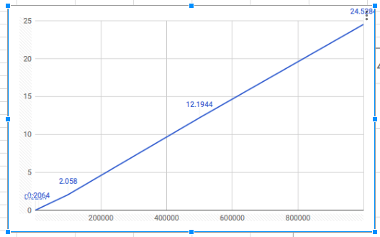

**Discussion:**

The first table and the graph just show the data straight up. The second graph though is determined on a scale of log(n). As is apparent the graph is a linear graph on a log scale showing that it is a n*log(n) time complex.

Real vs Theoretical:

Finding the constant of proportionality:

time = k*nlog(n)

.2064 = k*10,000(log(10,000)) = 40,000

K = 0.00000516

2.058 = k*100,000(log(100,000)) = 100,000

K= 0.00002058

12.1944 = k*500,000(log(500,000)) = 500,000

K= 0.0000243888

24.5284 = k*1,000,000(log(1,000,000)) = 6,000,000

K= 0.000004088066667

Average k = 0.000013554216667 = 1.36 * 10^6

Since the constant of proportionality is so small, the difference of the theoretical and empirical estimates of time complexity is almost negligible.

Pictures:

100:

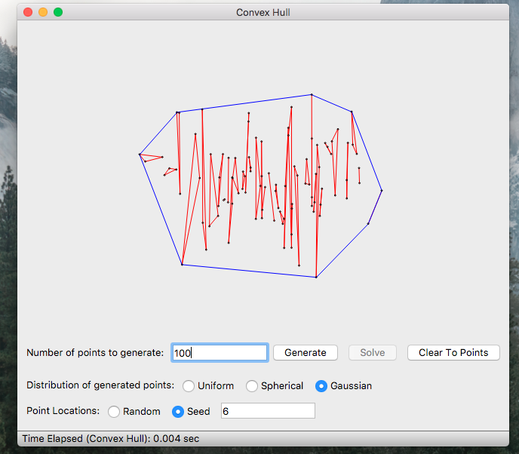

1000:

